Assignment 1 - Modeling a System



Art galleries are increasingly leveraging technology to manage their collections, exhibitions, and interactions with both artists and patrons. A robust database system is necessary to, enable the gallery to organize, display, and sell artwork efficiently.

In this assignment, you will be designing a relational database system to help an art gallery manage their data.

# Details of the System

This system meticulously records details of artists and their artworks. Each artist is linked to a profile that encapsulates biographical information, showcasing a portfolio of their works and including essential contact details. Artworks are systematically cataloged within the system, detailing the title, creation year, medium, and dimensions, while associating each piece with its creator. The artworks' status within the system is dynamically managed, indicating whether they are available for display, currently sold, or loaned out for exhibitions.

The system's functionality extends to managing galleries and the exhibitions they host. It captures specifics about different galleries, such as their geographical locations and sizes, and tracks the exhibitions arranged within these spaces. Exhibitions are pivotal events where artworks are presented to the public, with clear definitions of their start and end dates. Given the nature of exhibitions to feature multiple artworks and for artworks to be displayed across various exhibitions over time, their relationship within the database is inherently many-to-many.

Customers engage with the gallery through both physical visits and online platforms, where they can explore artworks, learn about artists, and keep abreast of forthcoming exhibitions. The system facilitates artwork purchases by processing sales transactions, which involves recording the sale's details, including the transaction date, the artwork's price, and the buyer's information. Moreover, it maintains customer profiles to foster ongoing communication and offer tailored recommendations based on historical interactions and expressed preferences.

To accommodate online interactions, the system includes user accounts for artists and customers. These accounts are tailored to different roles within the system, allowing artists to update their profiles and list new artworks, while customers can view and purchase artworks.

The operational backdrop of the system involves handling inventory and supply chain management for the gallery. This includes not just the artworks but also art supplies and merchandise. The system manages relationships with suppliers who provide these materials and goods, facilitating the tracking of inventory levels, placed orders, and received items.

# Assignment Tasks

In this assignment, you will develop a relational database model that can be used to implement the art gallery system.

You will need to develop 3 entity-relationship models at the conceptual, logical, and physical levels using 2 different tools.

## Conceptual Model

Using Visual Paradigm Online (<https://online.visual-paradigm.com/diagrams/features/erd-tool/>), draw a conceptual entity relationship model representing the art gallery system. You are allowed to create an account on that website to save your data as you work. If you feel adventurous (i.e. this is not a requirement), you could even download a copy of Visual Paradigm and create the diagram in the tool. No instructor help will be provided for the usage of the tool but there are many tutorials online.

In the conceptual model, remember that we are only concerned with the entities and the relationships (<https://online.visual-paradigm.com/knowledge/visual-modeling/conceptual-vs-logical-vs-physical-data-model/>). We do not worry about keys or the types of attributes. At this point, we do not resolve many-to-many relationships. If you add these additional items, your grade will be lowered.

The conceptual model is a very useful starting point when designing a system because you can focus on what is being captured without worrying about details such as keys or even attributes.

When you are finished with the model, export the model as a PDF file and submit to the dropbox. Make sure to name the file ‘conceptual_model.pdf’ and make sure that no details of your model are obscured by the watermark in the upper right corner of the diagram.

## Logical Model

Using Visual Paradigm Online, make a copy of your conceptual model and expand it to become the Logical Model by adding attributes, primary keys, and foreign keys. Please clearly label primary keys with (PK), foreign keys with (FK), and primary & foreign keys as (PK,FK) in addition to the bold and italic styling. Make sure that the bridge tables have reasonable names.

When you are finished, export the file as a PDF and submit to the dropbox using the name ‘logical_model.pdf’. Ensure that no details of your model are hidden by the watermark in the upper right corner of the diagram.

## Physical Model

Using MySQL Workbench, create the Physical model. You must use MySQL Workbench for this part of the exercise, not Visual Paradigm! Solutions submitted using Visual Paradigm will not be graded. In the physical model remember that all details must be included such as the types of the attributes.

In the completion of your assignment, it is required that the logical and physical models adhere to the Third Normal Form (3NF) standard. This requirement ensures that the database design is optimized for efficient data retrieval and maintenance, minimizing redundancy, and avoiding update anomalies. As you develop your ERD, carefully consider the structure of your entities and relationships, ensuring that all attributes are fully functional and only dependent on the primary key within each table.

# What to Submit

* The conceptual model of the art gallery as created by Visual Paradigm Online tool in PDF format. The generated PDF will contain a watermark of the tool that is okay.
* The logical model of the art gallery as created by Visual Paradigm Online tool in PDF format.
* The MySQL workbench file containing the physical model. The model needs to have consistent naming and must include all keys and attributes.
* The model diagrams must be “clean”. There should be no (or at least minimal line crossings) and the elements must be arranged so that they are easy to read. Points will be deducted for diagrams that have arrangement issues.

# Due Date

This assignment is due on May 23, 2024 at 11:59pm. Late submissions will be accepted until May 25 at 11:59pm with a 50% penalty.

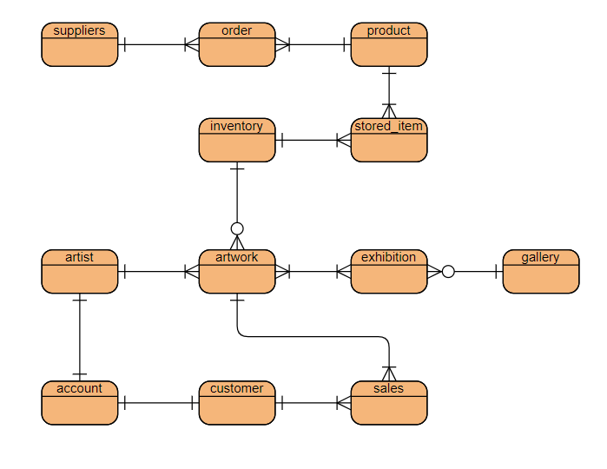

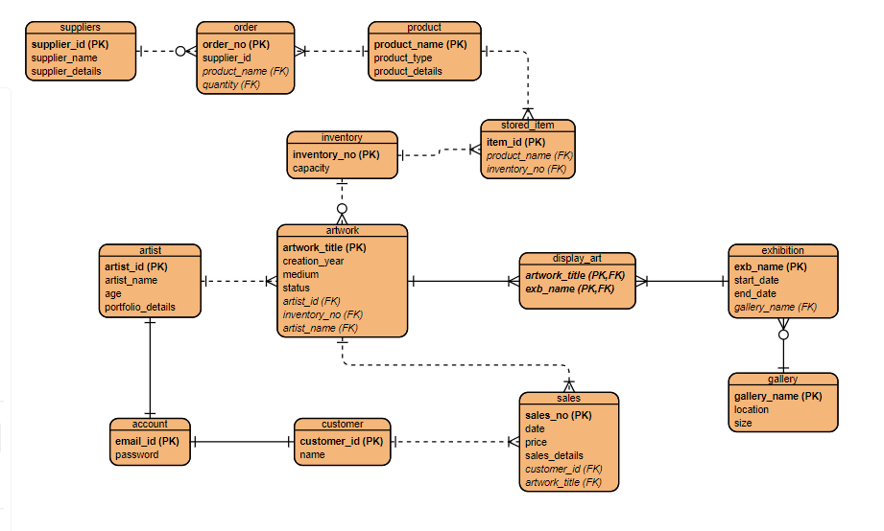

Total Points: 50

|  |  |  |  |  |
| --- | --- | --- | --- | --- |
| **Criteria** | **Exemplary** | **Satisfactory** | **Developing** | **Unsatisfactory** |
| **Conceptual Model: Entities Identification** (10 Points) | All entities are identified accurately, showing a deep understanding of the system. (10) | Most entities are correctly identified, minor inaccuracies. (7) | Some entities are identified, several inaccuracies. (4) | No correct identification of entities. (0) |
| **Conceptual Model: Relationships and Cardinality** (10 Points) | Precise representation of all relationships and cardinalities. (10) | Most relationships and cardinalities are correct with minor errors. (7) | Some relationships and cardinalities are correctly identified, but with multiple errors. (4) | Incorrect or missing representations. (0) |
| **Logical Model: Attribute Mapping** (10 Points) | Correctly maps attributes to all entities. Correct assignment of foreign keys. Correct usage of identifying and non-identifying relationships (10) | Most attributes are correctly mapped, with minor errors or omissions. Most foreign keys and relationship types are correct. (7) | Some attributes, foreign keys and relationship types are correctly mapped, but several errors or omissions. (4) | Incorrect or incomplete attribute, foreign key or relationship mapping. (0) |
| **Physical Model: Table Definition and Primary Keys** (10 Points) | Accurate definition of tables and correct assignment of keys. (10) | Most tables and keys are defined correctly, with minor inaccuracies. (7) | Some correct table definitions and key assignments, but numerous inaccuracies. (4) | Incorrect or incomplete table definitions and key assignments. (0) |
| **Logical and Physical Model: Normalization to 3NF** (10 Points) | Comprehensive application of normalization principles, achieving 3NF with no redundancy. (10) | Mostly adheres to 3NF, slight redundancy or dependency issues. (7) | Partial adherence to 3NF, notable redundancy and dependency issues. (4) | Does not adhere to 3NF; significant redundancy and dependency issues. (0) |